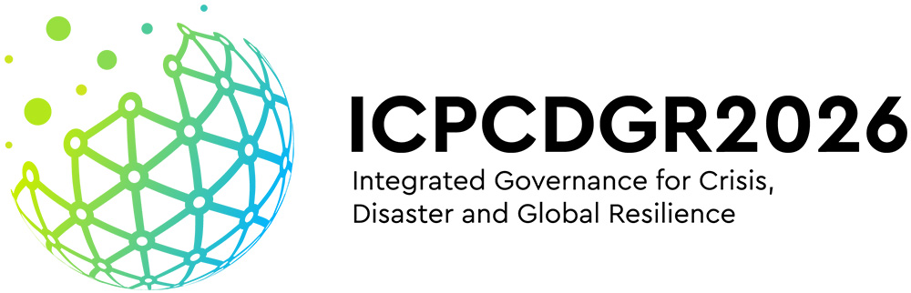
INTERNATIONAL HYBRID CONFERENCE
KAVALA, 6-7–8–9 MAY 2026

ABSTRACT TITLE (CALIBRI, 14 FONT SIZE, BOLD, ALL CAPS, CENTERED)

Author’s Name and Surname¹, Author’s Name and Surname², Author’s Name and Surname³ (10 font size)
^{1, 2} Authors’ Department, Institute (country)
(E-mail: firstauthorsname@aaaa.bbb, secondauthorsname@aaaa.bbb)
³ Author’s Department, Institute (country)
(E-mail: thirdauthorsname@aaaa.bbb)

Keywords: Up to 5 keywords regarding the work, written with font size 10 and separated with commas.

The abstract should be between 500 and 800 words, using font size 11, Calibri, justified, and single-line spacing. Please leave one line between paragraphs and do not indent the text. All abstracts should be written in English.

If necessary, any bibliographic sources should be presented with numbers in brackets (i.e., ‘[ ]’) in the abstract and listed at the end of the manuscript, according to their order in the text. References should be presented in the reference style shown at the end of this page (font size 10, Calibri). The number of bibliographic references should not exceed five (5).»

Page size is A4, and page margins are set at 2.5 cm from right, left, top, and bottom. Lines should be aligned to the right, and there should be no text hyphenation. Pages should not be numbered. Abstracts should not exceed 2 pages, including any references, if any.

The abstract will be used by the Scientific Committee as the basis for determining whether it will be accepted for oral and/or poster presentation. Authors are requested to submit their abstracts in electronic form (Word or similar form), using the website of the IDRiM2026 Conference.

If you have any questions about the abstract format or submission, please contact the organizing committee at: icpcdgr@gmail.com

REFERENCES

- S. Smith, J. Johnson, W. Li (2022). Disaster risk reduction in islands. Scientific Journal, 27, 2656-2662. Doi: xxx

